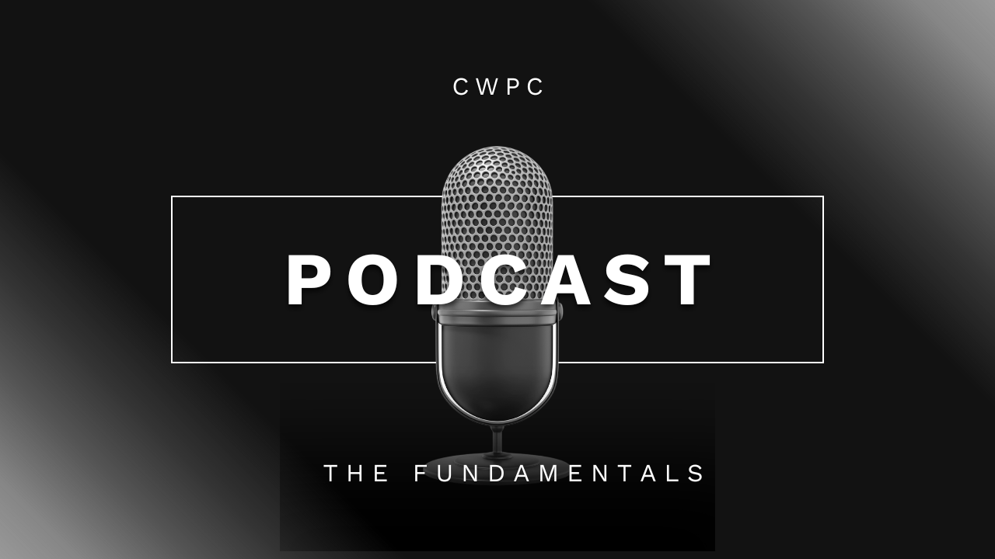

The Fundamentals of Starting a Podcast

The basics

What is our podcast?
Video with cameras on as we interview someone (Past Innovation Showcase presenter)
Podcasts have two components:

- Idea
- Voice

What is a video podcast, and should we try making one?
Video podcasts (mp4) get more news than voice (mp3) ones.

Have CWPC logo on the bottom-right.
Zoom preferred.
CWPC Zoom themed backgrounds

The Essential Steps

Idea: What is the big picture
- Interview previous podcast presenters to learn what they are doing currently and how they are changing their communities.
- Big Goal: How they are tackling wildfires and creating wildfire resilience → Climate Change

Topics: What are potential topics our podcast covers
Explore the journey of past showcase presenters, including:
- Origin Stories – what sparked their idea and how it all began.
- Life After the Showcase – the doors that opened and the paths that followed.
- Pivots & Challenges – the hurdles, surprises, and lessons learned.
- Ripple Effects – the unexpected impacts on opportunities, community, inspiration, and personal growth.
- Future Horizons – where their project or career is heading next.
- Advice for Others – insights for new presenters and aspiring innovators.

What makes our podcast unique? Why are we doing this?
CWPC is a nexus for community members, innovators, and policymakers. Changemakers.
- Showcase community connection
  - Tying together past presenters into a shared story of progress and possibility
  - Ultimately, it strengthens the CWPC community by providing members a spotlight and a voice.

Podcast Format
Will interview guests with expertise in specific areas
- The interview podcast
  - Interview a different guest every episode.

Podcast Target Audience
Goal: Define the CWPC audience who will engage with us and the podcast ‍
- Your niche
  - Past Innovative Showcase presenters whose product/company focus on wildfire resilience
- The kinds of people who would be interested in consuming content about it
  - Individuals/ companies who have an interest in climate change
  - Business/ professional sectors
- How you can best reach them.
  - CWPC social media channels
    - TikTok, Instagram, YouTube, LinkedIn, Facebook

Podcast Branding

Podcast Name
No more than 4 words
Dont have to include “podcast” in the title
Examples:
- Resilient by Design
- Beyond the Burn
- Spark Talks
- Fireside [or Wildfire] Chats
- Edge of the Flame
- Ember to Action
- Future Firebreaks
Note: Will need to find out if other podcasts have a subtitle if they represent an rganization
Example → Beyond the Burn: A CWPC podcast about wildfire resilience
Include keywords our audience will search for when scanning through podcasts → climate change
- Use podcast name ideas for help creating a podcast name!

Signature Podcast Intro/Outro
Need to reflect our podcast identity
- Intro sets the first impression and hooks listeners
- Outro leaves them with a lasting connection.
  - Call-to-action (CTA) → Choose ONE
    - Extension activity
      - Poll for what listeners want to hear next
      - Send their questions
      - Follow us on social media → show social media logos
      - QR code → Subscribe to CWPC website

Develop Podcast Trailer
A quick introduction to the CWPC podcast and highlighting what makes it unique and worth listening to.
Trailer length: 2 minutes maximum; Include music used in podcast
Worth including in the trailer:
- Introduction
  - Name of Podcast and niche
- What audience can expect from the podcast
  - Guests, how often show occurs,
- Hook
  - Thought-provoking question or clip of recent wildfire
- CTA
  - Encourage people to follow on social media/website
  - Encourage people to watch first episode

Podcast Music
Need to view other podcasts determine how many music selections they have.
Intro/Outro same music
Different middle break section music
Resources
- Pixabay.com

Podcast Equipment
Can host video interviews from computer to specified platform
- Computer to record video interviews requires paid Zoom/ Google Meet account
- Can hold interviews through Riverside, via Spotify for Creators
  - Utilizes AI tools and editing features

Equipment
Recording Equipment
- Can use earbuds → Cheapest option → Blocks out ambient environment sounds
  - Use both at same time! Fully charged!
- Computer recording →picks up environment background sounds
Microphone
- Recommended ones from Spotify are too expensive
Decent webcam
- Most built on computer cams are decent
Best time of day to record video for optimal lightning
Needed Items for Podcast Imagery
- CWPC themed Zoom/ GoogleMeet background
CWPC logo with gradient
Check out this equipment guide for more information on optimal podcast information.

Record the First Podcast Episode

Pre-production
Quality = consistency
Pre-Production points include:
- Outline topics
- Pick guests to interview
- What listeners want to know/hear
Create a podcast planning template to anticipate tasks tht need to be completed and when
- Episode script
- Questions/ Questions not to ask
- When to reach out via email for guest confirmation
- When to initially reach out with guest invitation
- Interview time/date/platform
- Maybe: create survey for afterwards to gauge their experience and learn what we can do better/ what they liked

Podcast Recording
Before you start recording your first episode, pause and make sure you’re set up for success:

- Is your recording equipment ready? →Pick Zoom/ GoogleMeet
- Are your devices charged? → Earbuds/headset + laptop + Ipad/phone
- Is your script or outline where you can see it? →use Ipad/phone or second monitor
- How is your Wi-Fi connection?
- If you have guests you’ll interview remotely, are they ready with a quiet space to record and good WiFi signal, too? → check with them before recording!
- If you’re filming a video podcast, are your lights and cameras placed correctly? → Using backgrounds for this reason plus daytime interviews when possible!

Post-production
Big Plan: Plan episode structure before editing!
Think: What is the goal of each section?
Podcast Episode Description
- Episode title + description.
- Optional: Episode artwork
How to write effective episode descriptions
- What keywords come to mind?
  - Guest names, location (local/global), topics
  - Keep it concise (three sentences at most)
  - Ensure your title and description work well together
  - Avoid repeating the information you provide in the title

Explore how to brand episodes effectively

